**AI Enable car parking using OpenCV**

Submitted by

Sai thanmay.A

Manishwar.K

Sai Gopal.P

Varshith.C



**1.**

**INTRODUCTION**

**1.1**

**Project Overview**

Most

AI-enabled

car par

king systems

parking

a

car today

are

still

managed

by

hand.

There

is

no

automated

monitoring

system

in

place

to

keep

track

of

how

much

capacity

each

parking

place

contains.

In

order

to

find

an

empty

spot,

drivers

often

have

to

make

a

circuitous

trip

through

the

parking

lot.

Where

there

are

more

people

than

parking

spots,

such

problems

are

especially

common

near

hospitals,

malls,

schools,

and

other

large

gathering places.

**1.2**

**Purpose**

The

purpose

of

using

AI-enabled

car

parking

systems

with

OpenCV

(

Open

Source

Computer

V

ision)

is

to

automate

and

optimize

the

process

of

parking

vehicles

in

a

parking

lot

or

gar

age.

By

employing

computer

vision

techniques

and

AI

algorithms,

these

systems

can

efficiently

detect

and

track

vehicles,

analyze

parking space availability

, and guide

d

rivers

to vacant spots.

**2.**

**IDEA**

**TION & PROPOSED SOLUTION**

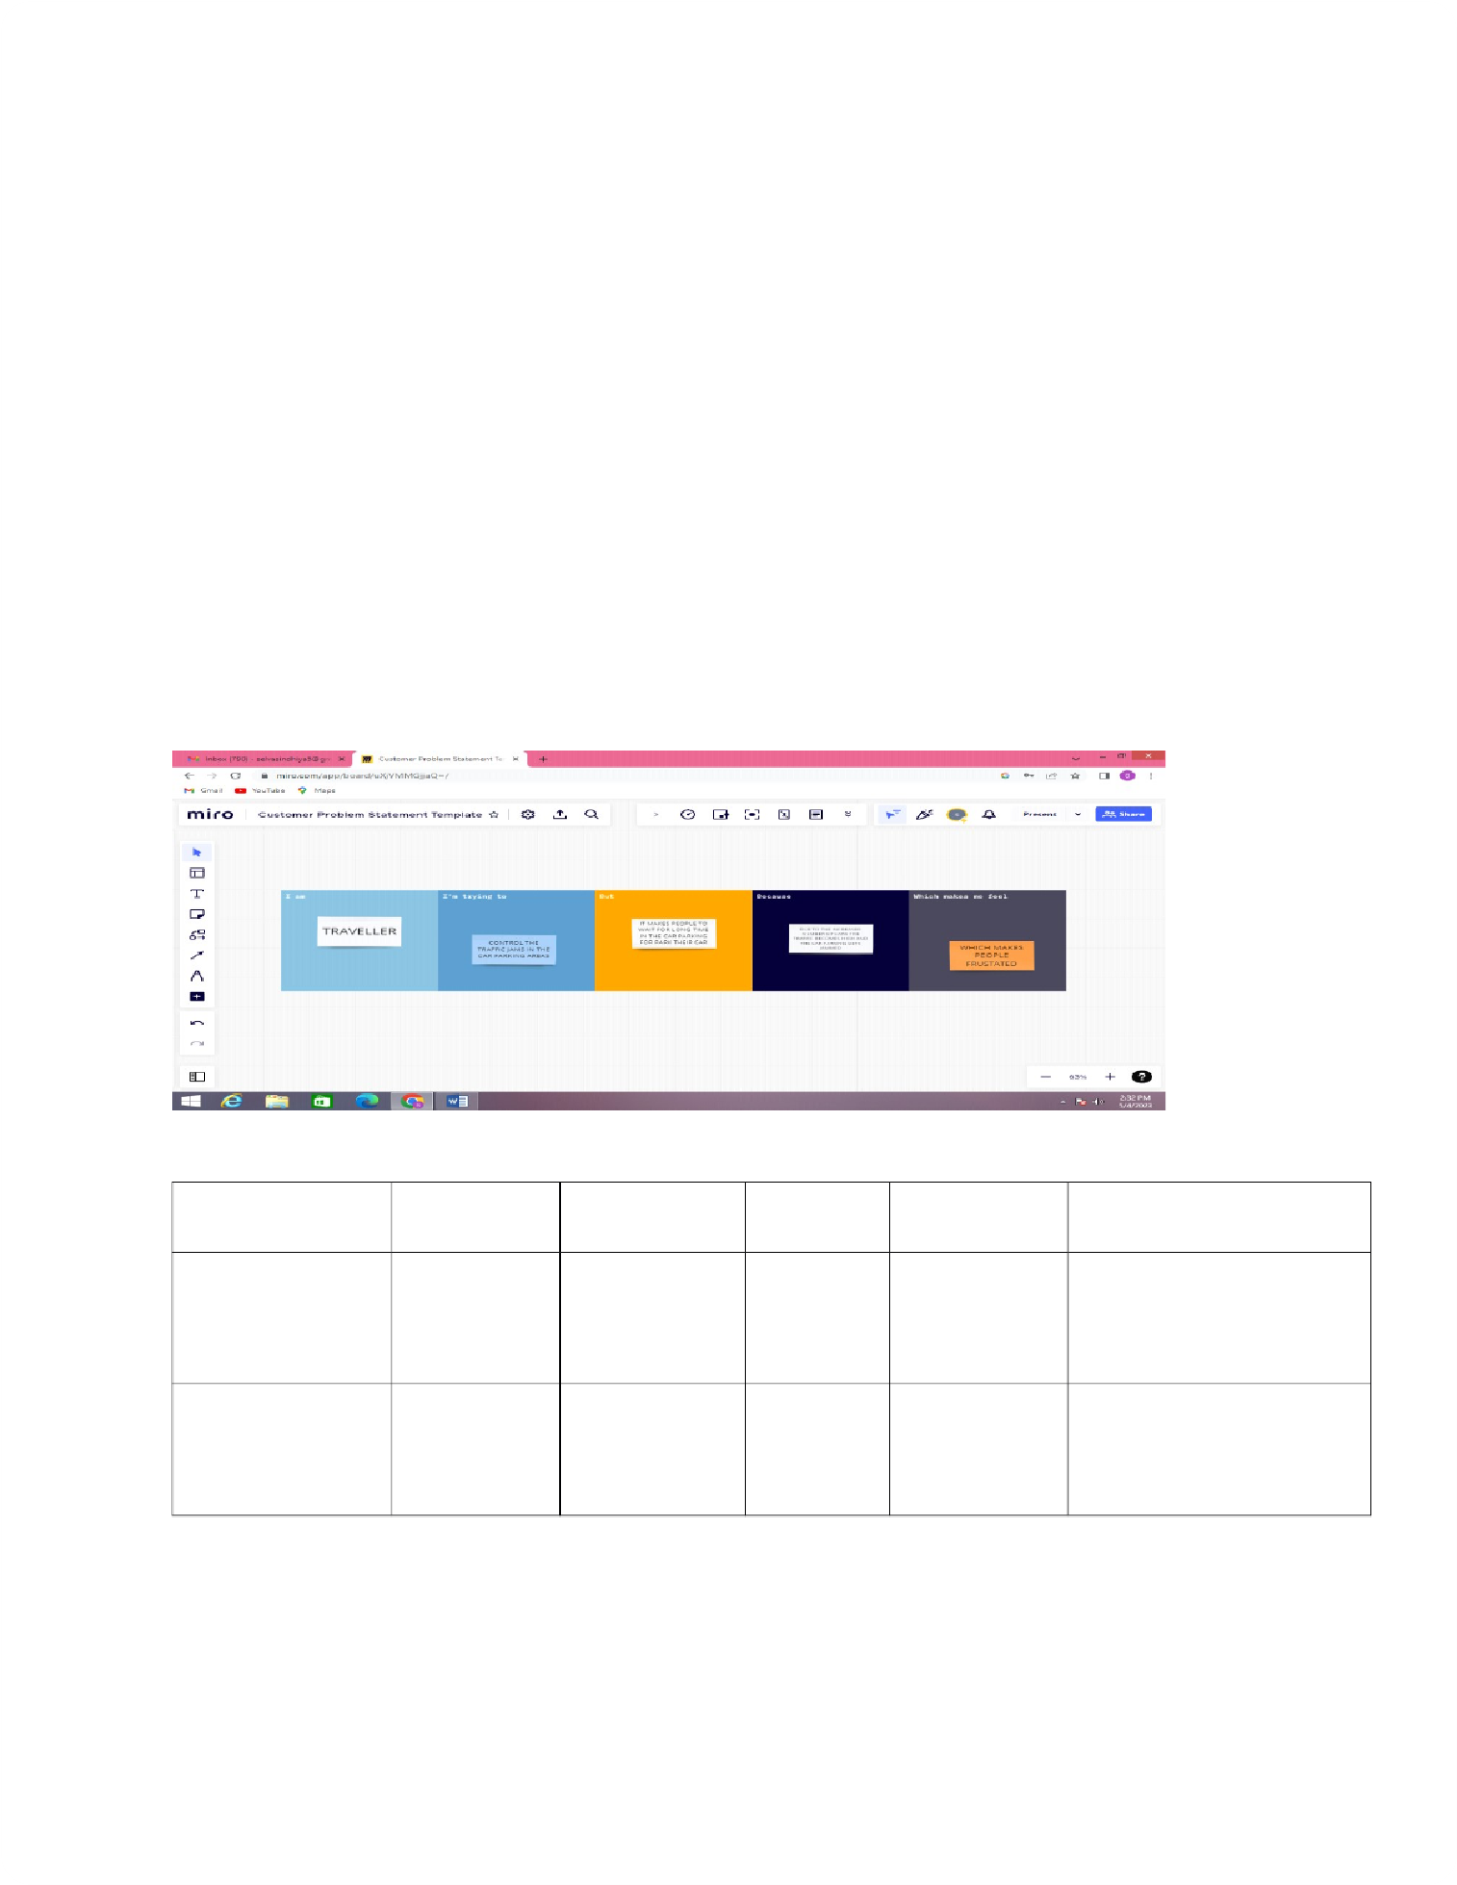

**2.1**

**Problem Statement Defini**

**tion**

**Customer Proble**

**m Statement template:**

Problem statement

1

:

Consequently

, once a car enters a parking garage followed

by a parking space, a ping ultrasonic

sensor will then be able to determine if a car is parked in the space or not.

This information

would then be relayed to

update the network.

Problem statement 2

:

A

void excessive parking supply

. Use Parking Management to encourage more ef

ficient use of

existing parking facilities and address any spill over problems that result from

pricing. Develop

T

ransportation Management Associations to

provide pa

rking

manageme

nt

and brokerage

services in a

parti

cular

area.

**Pr**

**oblem**

**Sta**

**temen**

**t (PS)**

**I am**

**(**

**Cust**

**omer)**

**I’m trying t**

**o**

**But**

**Because**

**Which mak**

**es me feel**

PS-1

T

raveller

Control the

traf

fic in car

parking

It makes

more time

Due to the

increased

number of

cars

Frustrated

PS-2

T

raveller

Make the

traveller to

feel

automated

It makes

more time

Incre

ased

traf

fic

Frustrated

**2.2**

**Empathy Map Canvas**

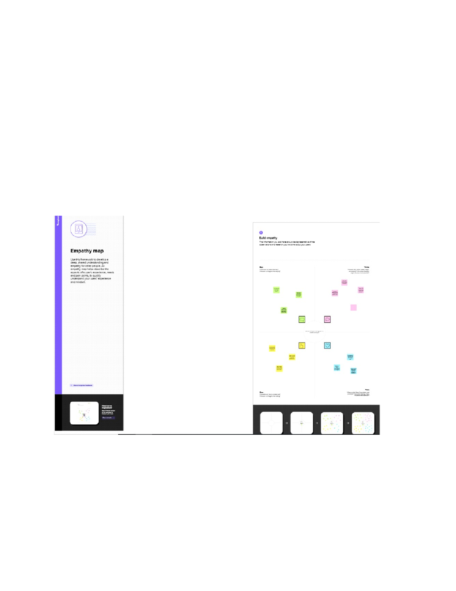

**Empathy Map Canvas:**

An

empathy

map

is

a

simple,

easy-to-digest

visual

that

captures

knowledge

about

a

user

’

s

behaviours and attitudes.

It is a useful tool to

helps teams better understa

nd their users.

Creating

an

effective

solution

requires

understanding

the

true

problem

and

the

person

who

is

expe

riencing

it.

The

exercise

of

creatin

g

the

map

helps

participants

consider

things

from

the

user

’

s

perspect

ive along

with hi

s or her

goals and challenges.

**EXAMPLE:**

**2.3**

**Ideation & Brainstorming**

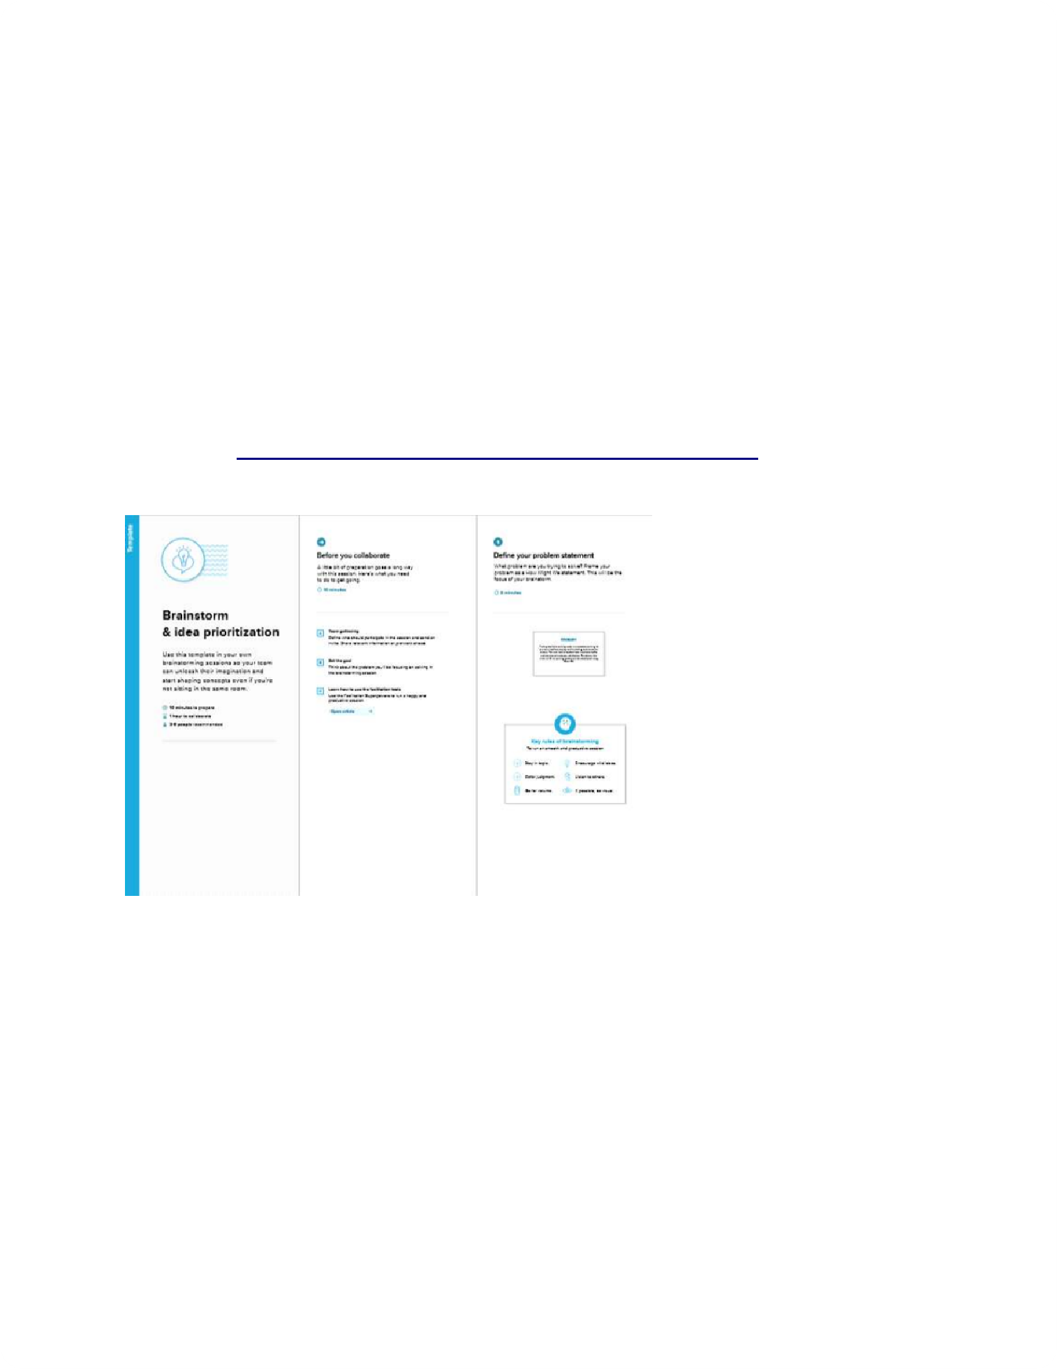

**Brainstorm & Idea Prioritization T**

**em**

**pla**

**te:**

Brainstorming

provides

a

free

and

open

environment

that

encourages

everyone

within

a

team

to

participate

in

the

creative

thinking

process

that

leads

to

problem

solving.

P

rioritizing

volume

over

value,

out-of-the-box

ideas

are

welcome

and

built

upon,

and

all

participants

are

encouraged

to

collaborate,

helping

each

other

develop a rich amount of creative solutions.

Use

this

template

in

your

own

brainstorming

sessions

so

your

team

can

unlea

sh

their

imagination

and

start

shaping

concept

s

even

if

you're

not

sitting

in

the

sam

e

room.

Reference:

https://www

.mural.co/templates/empathy-map-canvas

**Step-1: T**

**eam Gathering, Collabora**

**tion and Select the Problem Sta**

**tement**

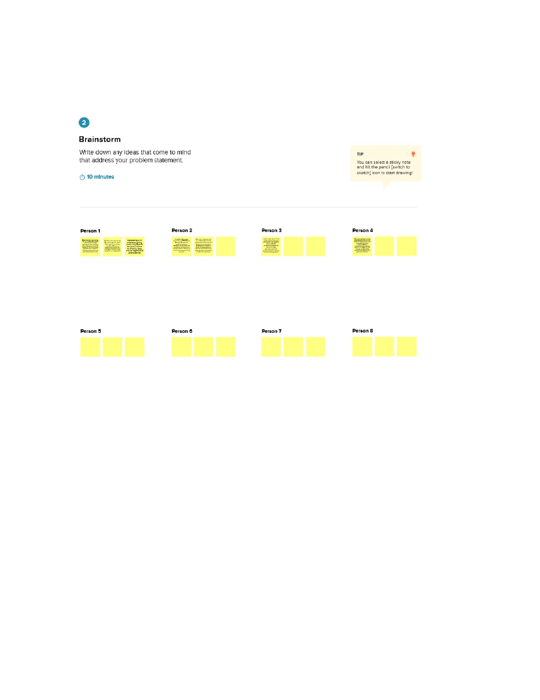

**Step-2: Brainstorm, Idea Listing and Gr**

**ouping**

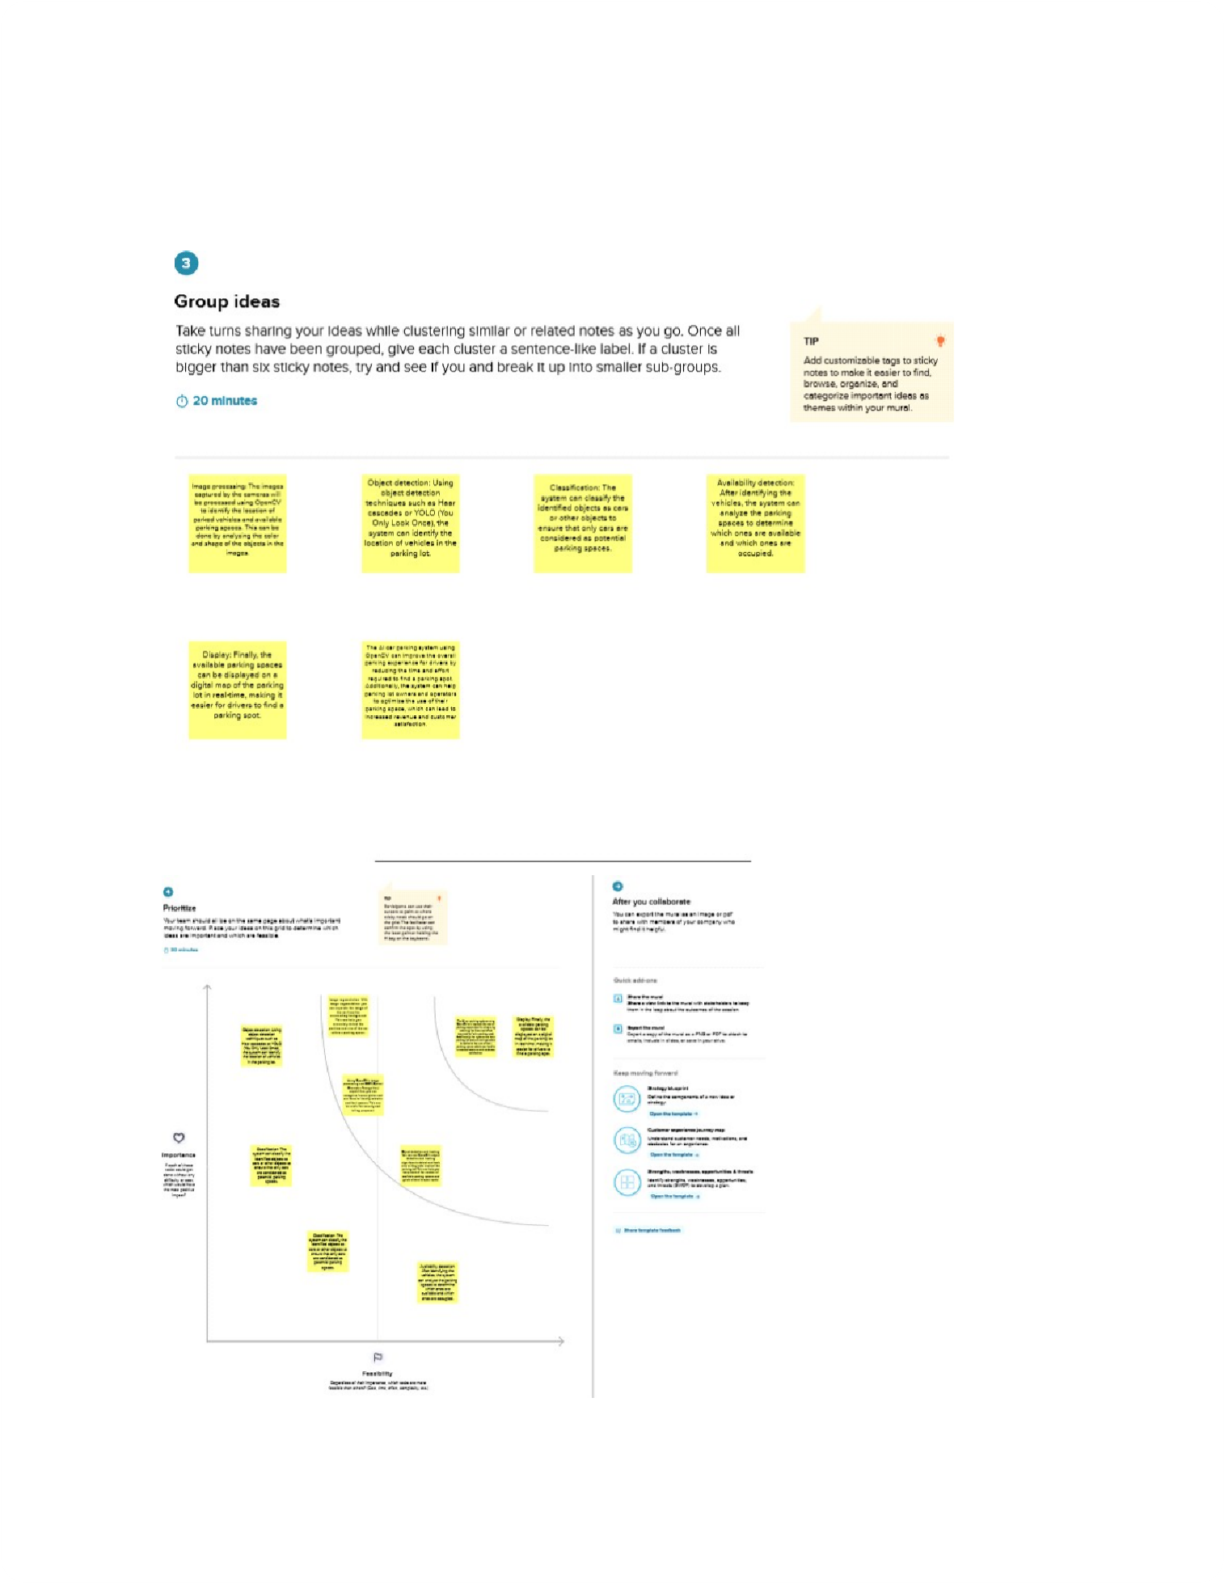

**Step-3: Idea Prioritization**

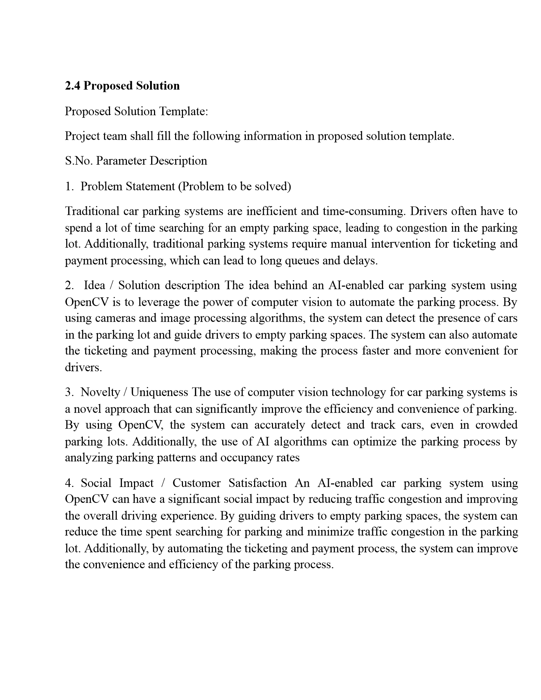

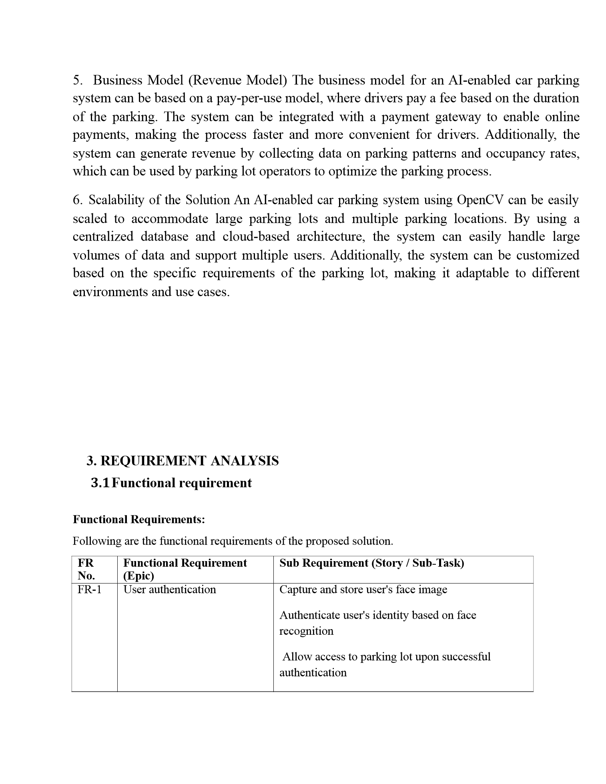



FR-2

Parking spot management

Detect availability of parking spots using

camera feed

Assign parking spot to the user

Update parking spot availability in real-time

FR-3

Payment and billing

Calculate parking fee based on parking duration

Allow payment via various modes like credit card,

mobile wallet

FR-4

Security and surveillance

Monitor parking lot using cameras for suspicious

activities

Alert

security personnel in case of any

security breach

FR-5

System maintenance and

support

Provide regular maintenance and updates to the

system

Offer custom

er support for any issues faced by

users

**3.2**

**Non-**

**Functi**

**onal r**

**equire**

**ments**

**Non-functional Requir**

**ements:**

Following are the non-functional requirements of the proposed solution.

**FR**

**No.**

**Non-Functional Requir**

**ement**

**Description**

NFR-1

**Usability**

The syst

em should be easy to use and user-

friendly

, providing clear instructions to drivers

on where to park and displaying available spots

in an intuitive

manner

.

NFR-2

**Security**

The

system

should

be

secure

and

able

to

prevent

unauthorized

access

to

the

parking

lot.

It

should

also

protect

the

data

collected

by

the

system,

ensuring

that

it

cannot

be

accessed

by unauthorized parties.



NFR-3

**Reliability**

The system must be reliable and accurate in

detecting and identifying available parking

spots. It should also be able to

identify and

prevent unauthorized access to the parking

lot

.

NFR-4

**Performance**

The system must be fast

enough to detect

and

identify available parking spots in real-time,

allowing drivers

to quickly find

a parking

spot.

It should also be able to handle multiple

vehicles entering and exiting the parking

lot

simultaneously

.

NFR-5

**A**

**vailability**

T

he system should be compatible with different

types of vehicles, including cars, trucks, and

motorcycles, and be able to

accommodate

diffe

rent

sizes of vehicles.

NFR-6

**Scalability**

The sy

stem should be able to handle a large

number of parking spaces, and be easily

scalable

to accommodate additional spaces in the future.

**4.**

**PROJECT DESIGN**

**4.1**

**Data Flow Diagrams**

**Data Flow Diagrams:**

A

Data Flow Diagram (DFD) is a traditional visual representation of the

information flows within a system.

A

neat and clear DFD can depict the right

amount of the system requirement graphically

.

It shows how data enters and leaves

the system, what changes the information,

and where data

is stored.

**Example:**

**(**

**Simplified**

**)**

**+-------------+**

**+-------------+**

**+-----**

**--------+**

**|**

**Camera**

**|**

**|**

**Image**

**|**

**|**

**Parking**

**|**

**|**

**Sensor**

**| Images**

**|**

**Analysis**

**|**

**Spots**

**|**

**Status**

**|**

**+-------------+**

**+-------------+**

**+-------------+**

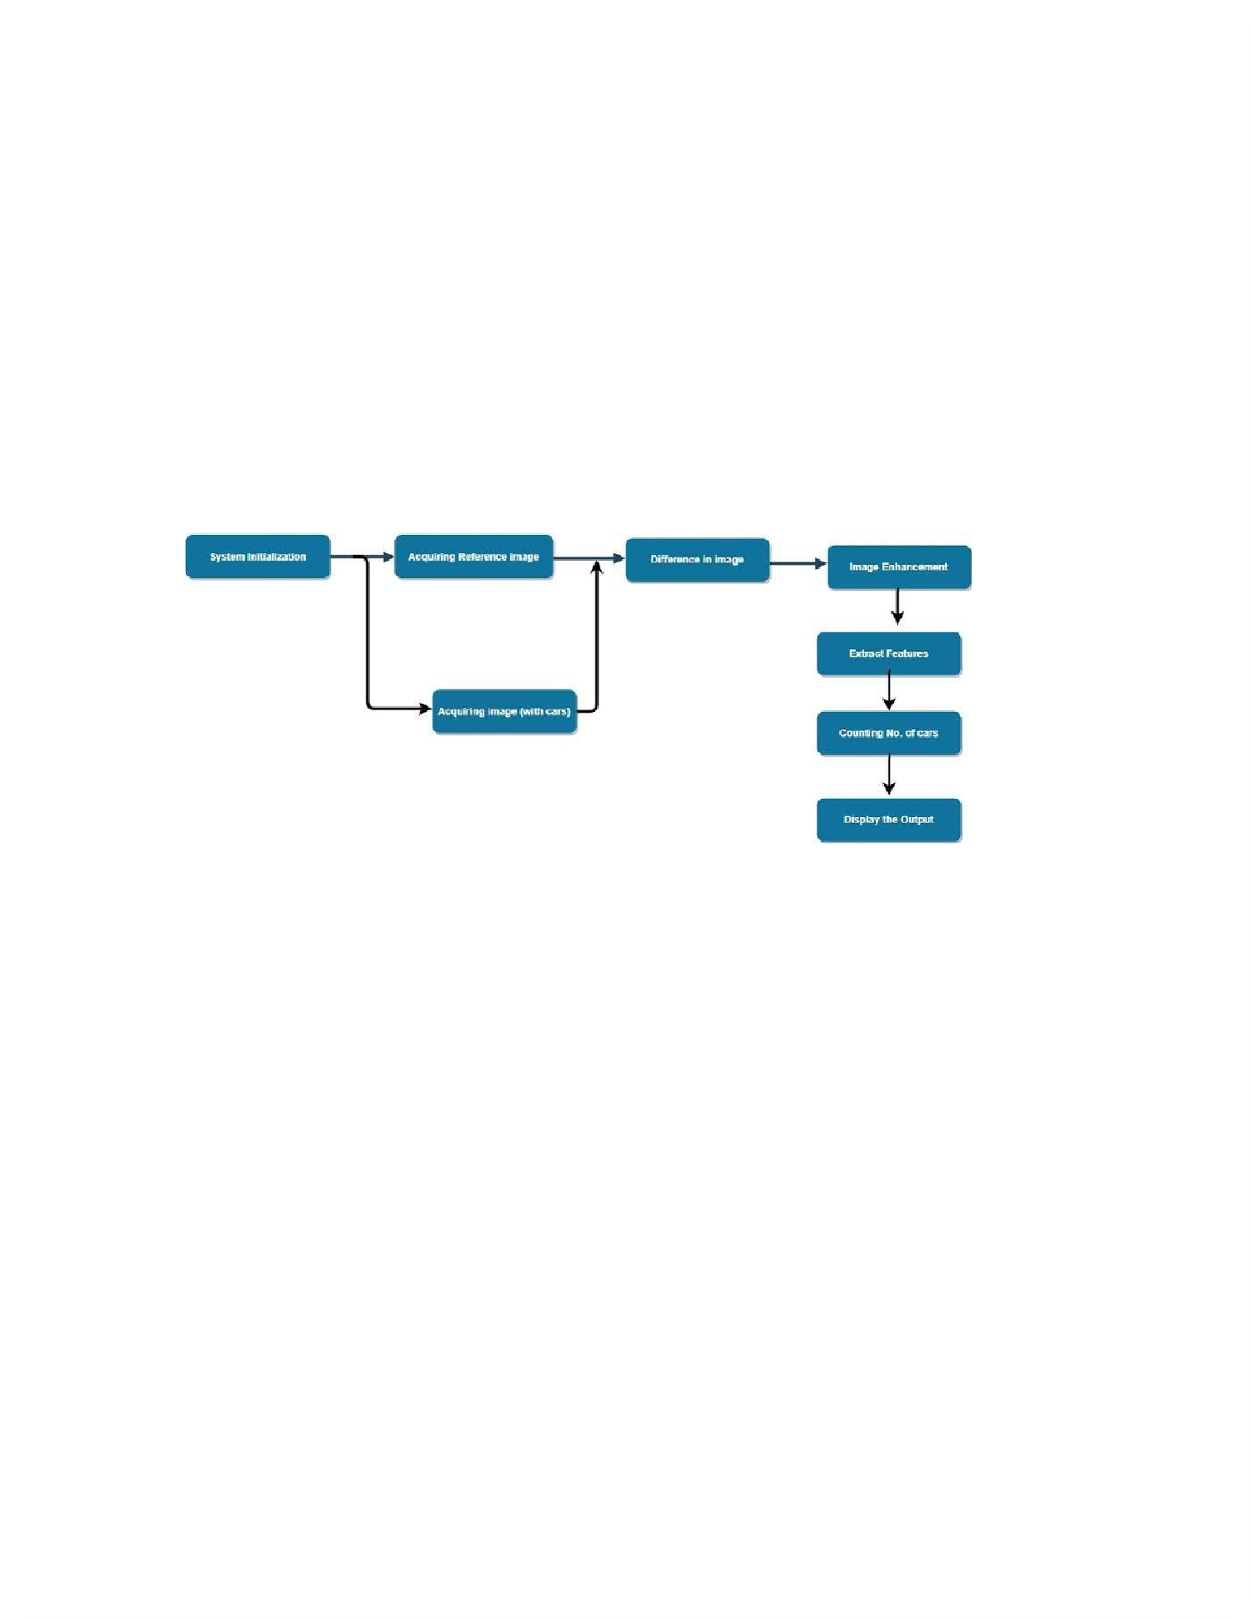

**|**

**|**

**|**

**|**

**| Parking Status**

**|**

**| Image Analysis**

**| Up**

**date**

**|**

**|**

**|**

**|**

**+-------------+**

**+-------------+**

**+-------------+**

**|**

**OpenCV**

**AI**

**|<**

**----------**

**|**

**Server**

**|<**

**----------**

**|**

**User/**

**|**

**|**

**Library |**

**|**

**Processing |**

**|**

**Operator**

**|**

**4.2**

**Solution & T**

**echnical Architectur**

**e**

**Solution Archi**

**tecture:**

Solution architecture is a complex process – with many sub-processes – that

bridges the gap between business problems and technology solutions. Its goals

are to:

●

Find the best tech solution to solve existing business problems.

●

Describe the structure, characteristics, behavior

, and other aspects of

the software to project stakeholders.

●

Define features, development phases, and solution requirements.

●

Provide specifications according to which the solution is defined,

managed, and delivered.

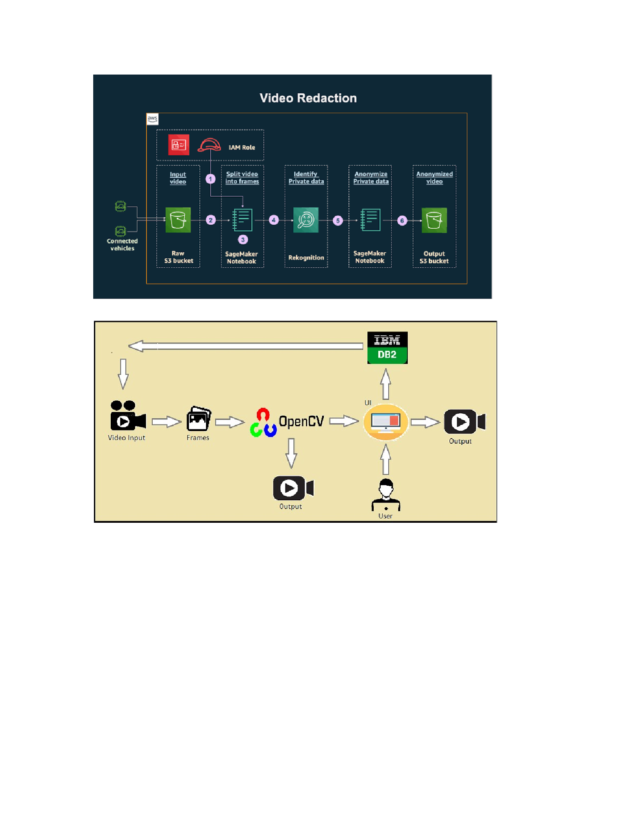

Example - Solution Architecture Diagram:

**Figur**

**e 1: Architectur**

**e and data flow of the car parking using open cv**

**.**

**4.3**

**User Stories**



**User Stories**

Use the below template to list all the user stories for the product.

Customer

Registration

USN-1

As a driver

, I want to be able to enter the

The algorithm can

High

Ragul

(

driver

)

parking lot and have the system detect

a

detect

empty parking

parking space so that I can park

my car

.

spaces with an accuracy

rate of at least 95%.

USN-2

As a driver

, I want to be able to reserve a

parking space so that I am guaranteed a

spot when I arrive.

The reservation system

can handle multiple

reservations at the same

time.

Medium

Ragul

USN-3

As a parking lot attendant, I want to be

The system provides

High

Ragul

able to monitor the parking lot in real-time

real-time updates of

so that I can manage the parking spaces

occupied and available

ef

fectively

.

parking spaces to the

attendant.

USN-4

As a parking lot owner

, I want to be able

The reporting system

Medium

Ragul

to generate reports on parking lot usage so

c

an ge

nerate reports on

that I can make informed decisions about

parking lot usage by

pricing and capacity

.

hour

, day

, and month.

T

r

ave

ller

USN-5

As a parking lot user

, I want to be able to

The mobile payment

Low

Sampath

pay for

my parking spot using my mobile

system is secure and

device so that I don't have to use cash or

a

uses encryption to

credit card.

protect user

information.

Dashboard

Customer

(

W

eb user)

Customer

Care

Executive

Administrator